Tenney Family Association (TFA)

The TFA is a premier national family association dedicated to the preservation of our proud Tenney heritage. Our progenitor, Thomas Tenney, arrived in the Massachusetts Colony in 1638. Membership is open not only to the descendants of Thomas Tenney, but also to anyone who has an interest in the Tenney surname or any of its variations. (Tinney, Tenny, etc.) The Tenney Family organization has been in existence since 1891, first as an informal family gathering followed by a more formal organization founded in the Hanover, NH area. Association records cite the first election of officers in 1925, and the formation of the TFA. The Association has met annually ever since!

We gather once a year to catch up on family news, to hold our business meeting, to have an enjoyable weekend full of activities, and to welcome new “cousins” who have joined the Association. The reunions are held at various locations throughout the US. Besides the annual reunion, many members of the Association work very hard all year long on other TFA projects, to insure that the Association will leave a proud legacy for all future Tenney generations. We publish a newsletter, entitled Tenney Times, four times a year, full of interesting articles about Tenney places, people and news. We maintain a Facebook page, and a message board on Rootsweb. The Association has in its archives old photographs, letters, books, newspaper articles along with hundreds of genealogical charts and manuscripts dating back over 80 years, written by and about Tenneys.

The Tenney Family Association is committed to sustaining the Tenney family name and heritage.

Association Officers and Board Members

2015 - 2017

President – Debbie Montgomery, CA
Vice –President – president@tenneyfamily.org
Treasurer – Jim Tenney, VA
Secretary – secretary@tenneyfamily.org
Webmaster – webmaster@tenneyfamily.org
Genealogist – Debbie Montgomery, CA
Curator – curator@tenneyfamily.org
Membership Chair – membership@tenneyfamily.org
Tenney Times Editor –editor@tenneyfamily.org
Merchandise Manager – Nancy Taylor, AZ Corporate Agent & Cemetery Specialist –
president@tenneyfamily.org

Database Administrator – Gregory Hancock, AZ

Facebook Administrator—webmaster@tenneyfamily.org

Visit us on line at: www.tenneyfamily.org www.facebook.com/TenneyFamily Contact us at:
membership@tenneyfamily.org

You are invited to join the

Tenney Family

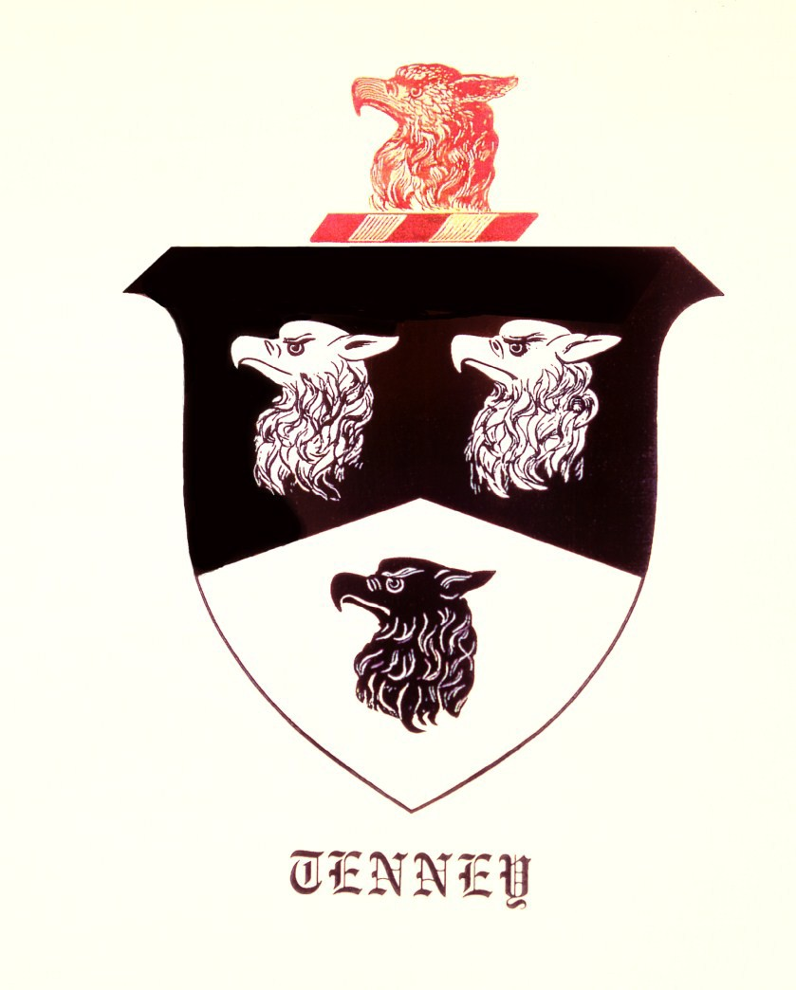Association, Inc.

One of the benefits of Membership in the Tenney Family Association (TFA) is a member discount on TFA merchandise, available from our website. This is just a “sample:”

The Tenney Family
Descendants of Thomas Tenney

A set of four volumes that update the M.J. Tenney 1904 book, tracing the descendants of Thomas Tenney, from 1638 to 2004. These volumes bring three traced lined of Thomas and Ann (Mighill) up to 2004. The volumes include an additional 15 — 19 generation and traces the three previously unknown lines. These updated genealogies are the leading resource publication that details our family heritage. All 4 volumes are available today!

Tenney Family Merchandise

Need a gift? Check out our Merchandise page on the web site. Unique items produced by the Association, as well as a link to Café Press.
Want to recognize a birthday, anniversary, special event, or your business? Contact Merchandise@tenneyfamily.org

Genealogy resources

Searching for your roots? Want others to know of your Tenney lineage? Submit lineage, histories, etc. to our genealogist, genalogist@tenneyfamily.org or to TENNEY-L@Rootsweb.com

Sharing Your Story

If you would like to share your family history, a perfect venue is the Tenney Times. Submit your article(s) to Editor@tenneyfamily.org for publication in the quarterly newsletter.

Membership Benefits

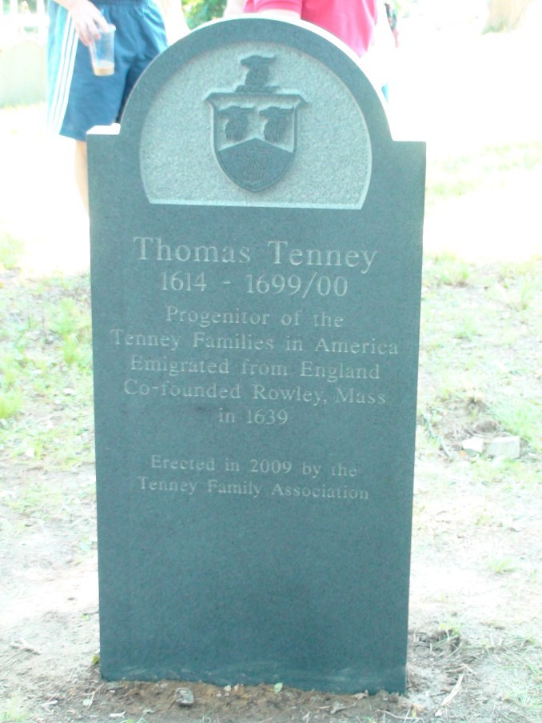Include discounts on Tenney merchandise and books; an email subscription to the quarterly newsletter, the Tenney Times; access to the Association’s archives and genealogy information as available; and one vote in the election of officers, and other issues, either in person at the annual meeting or by absentee ballot.
Tenney Family Association, Incorporated

(Established 1925)

Membership Application
Name _________________________________________
Address _______________________________________
_______________________________________
Telephone ___________ E-mail ____________________
Used only for TFA business

Lineage (If known): John _______ Thomas, Jr. ________
Daniel ____________ Other ____________
Please check one of the below membership types:
(All are annual memberships except for LIFE and BENEFACTOR)

Basic ($25.00)
Family ($40.00) Sustaining (75.00) Life ($300.00)
Benefactor ($500.00)
Includes Life benefits

If you want to receive the Tenney Times by USPS check here

Mail this application with your check made out to the

TENNEY FAMILY ASSOCIATION, INC

To

Membership

23466 Caminito Norte
Laguna Hills, CA 92653

membership@tenneyfamily.org

Or pay by PayPal at http://www.tenneyfamily.org

